74th Washington State Festival RV Parking helpful hints.
Below are locations found in an internet search for the Everett area. Poorly rated RV Parks were left off the list. This list is intended only as a guide for starting your own research. There is no “official” campsite and no shuttle service. We have contacted Evergreen Fairgrounds and will have information about availability there in early 2027. Please check the Yes box for RV on the registration form and we will get information to you when we have it.
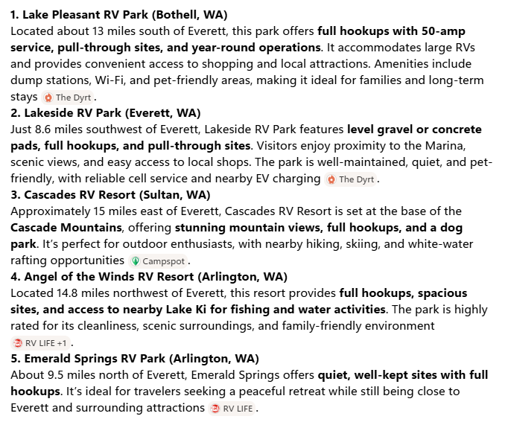
Submitted by Randy Lewis, info@sqdance.org

Harbour Point RV Park, Everett WA---8.1 miles SW
Tulalip Casino Resort, Tulalip WA---6.7 miles NW. Be sure to visit their website for requirements. Must obtain a free ONE membership.
Lake Ki RV Resort, Arlington, WA---11.7 miles NW
Cedar Grove Shores RV Park, Stanwood, WA---12.1 miles NW
Snohomish County Parks, Snohomish County Parks, www.snocoparks.org
For instant HELP see FAQs
Call Center assistance available M-F, 8:30am-4:30pm at 425-388-6600.
Note: Phones not monitored on weekends or legal holidays. Please expect longer wait times during peak season.
2026 Reservations Process was:
Reservations for picnic shelters, campsites, yurts, and cabins will be released in two phases:
Phase I:
- Begins at 9:00am (PST) on Monday January 5, 2026
- Reservations accepted for visits with check-out dates on or before June 30, 2026
Phase II:
- Begins at 9:00am (PST) on Tuesday February 17, 2026
- Reservations accepted for visits after June 30th (all of 2026)
Reservations for Yurts and cabins, with check-ins between December 31st and January 4th, can be made through the Call Center.
Flowing Lake Regional Park, also known as Leckie's Beach, is an immensely popular park that offers a variety of recreational activities. The day-use area provides access to the beach and amenities which include a boat launch, fishing dock, playground, picnic tables, picnic shelters and an amphitheater. For those that wish to stay a little longer, the park includes a campground with a mix of cabins and campsites and a heated restroom with showers. A nature trail encompasses a portion of the campground for those seeking a little solitude. Please note, the campground cannot accommodate 5th-wheel RVs exceeding 35'.
Wenberg County Park - Located on the eastern shore of Lake Goodwin, this award-winning park offers splendid opportunities for picnicking, sunbathing, boating, and camping. Within these 45 acres, you'll discover a 70-site campground, three picnic shelters, an enclosed swim beach with rinse shower, and 1,140 feet of freshwater shoreline with a two-lane concrete boat launch for your toys. Wenberg Park's campsites are situated within three campground loops offering full utility (water / power / sewer), partial utility (water & power), and non-utility sites.
Kayak Point - A spectacular saltwater beach park located along the shores of picturesque Port Susan. From its 3,300 feet shoreline to its evergreen forests, Kayak Point Park offers a beautiful setting for pier fishing, windsurfing, picnicking, hiking, camping, boat launching and more. In the day-use area, there are picnic shelters with an ocean view, beachside firepits, a playground, miles of beach to explore, a pier and restrooms. The pier extends 300 feet into Puget Sound and is a popular site for crabbing and fishing. At high tide, the water depth is 50 feet off the piers end.

