74th Washington State Festival RV Parking helpful hints.
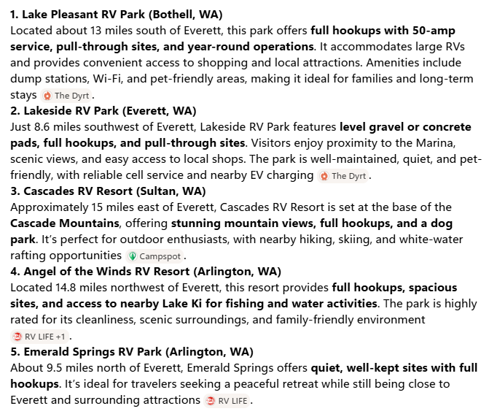

Harbour Point RV Park, Everett WA---8.1 miles SW
Tulalip Casino Resort, Tulalip WA---6.7 miles NW. Be sure to visit their website for requirements. Must obtain a free ONE membership. https://www.everythingtulalip.com/resort/rv-parking/
Lake Ki RV Resort, Arlington, WA---11.7 miles NW
Cedar Grove Shores RV Park, Stanwood, WA---12.1 miles NW

Snohomish County Parks, Snohomish County Parks, www.snocoparks.org

